# **Section 1: In-Network Service Chaining**

This section provides a step-by-step guide to setting up **In-Network Service Chaining** in OpenStack. The objective is to configure a **Service NAT VM** that allows communication between two networks (left-network and right-network).

## **Network Setup**

I created two networks in OpenStack:

### **Left Network (10.10.10.0/24)**

| openstack network create left-network openstack subnet create left-subnet \  --network left-network \  --subnet-range 10.10.10.0/24 |
| --- |

### **Right Network (2.2.2.0/24)**

| openstack network create right-network openstack subnet create right-subnet \  --network right-network \  --subnet-range 2.2.2.0/24 |
| --- |

## Creating the Service NAT VM

A Debian-based NAT VM is used to forward traffic between the two networks. Instructions on how I installed a Debian image are on “[Debian image installation](https://github.com/coflin/Network-Virtualization-and-Orchestration/blob/main/Service%20Chaining/pdf/Debian%20image%20installation.pdf)” doc.

| openstack server create \  --image debian-10-openstack-amd64 \  --flavor m1.small \  --nic net-id=$(openstack network show left-network -c id -f value) \  --nic net-id=$(openstack network show right-network -c id -f value) \  --key-name my-key \  --security-group default \  service-nat-vm |
| --- |

## Configuring NAT on the Service NAT VM

Once the Service NAT VM is running, SSH into it and configure IP forwarding and NAT.

### **3.1 Enable IP Forwarding**

| sudo sysctl -w net.ipv4.ip_forward=1 |
| --- |

Make it persistent:

| echo "net.ipv4.ip_forward=1" | sudo tee -a /etc/sysctl.conf sudo sysctl -p |
| --- |

### **3.2 Configure NAT for vm-right**

| sudo iptables -t nat -A POSTROUTING -o eth0 -j MASQUERADE sudo iptables -A FORWARD -i eth1 -o eth0 -j ACCEPT sudo iptables -A FORWARD -i eth0 -o eth1 -m state --state RELATED,ESTABLISHED -j ACCEPT |
| --- |

### **3.3 Configure NAT for vm-left**

| sudo iptables -t nat -A POSTROUTING -o eth1 -j MASQUERADE sudo iptables -A FORWARD -i eth0 -o eth1 -j ACCEPT sudo iptables -A FORWARD -i eth1 -o eth0 -m state --state RELATED,ESTABLISHED -j ACCEPT |
| --- |

### **3.3 Make iptables Rules Persistent**

| sudo apt update sudo apt install iptables-persistent -y sudo netfilter-persistent save sudo netfilter-persistent reload |
| --- |

## 

## Verification & Testing

### **4.1 Check NAT Rules**

| sudo iptables -t nat -L -v -n |
| --- |

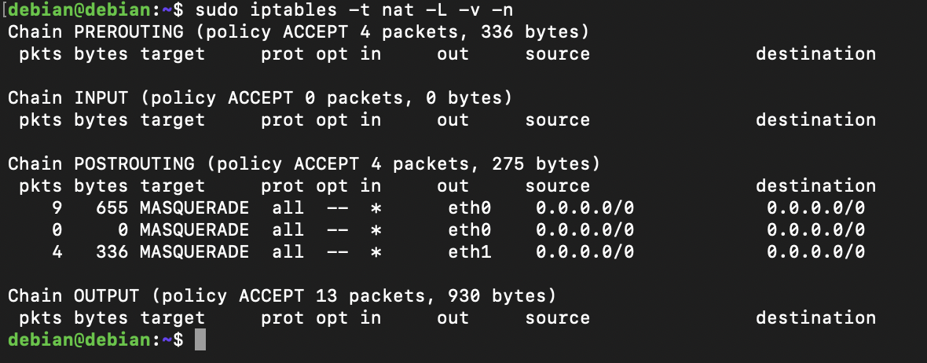

### **4.2 Verify ICMP Traffic in NAT Translation**

| sudo conntrack -L | grep icmp |
| --- |





**✅NAT is working** → The conntrack output shows that ICMP (ping) packets from vm-right (2.2.2.124) are being NAT-translated to vm-left (10.10.10.126) and vice versa.  
✅**ICMP replies are being received** → vm-left (10.10.10.126) is replying back to 10.10.10.186 (the Service NAT VM) and vice versa.

### **4.3 Test Connectivity**

#### **From vm-right to vm-left (*Should Work Through NAT*)**

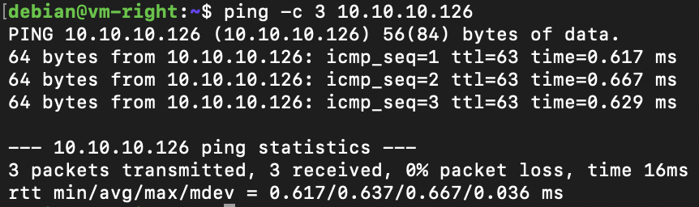

#### **Monitor Traffic on NAT VM**

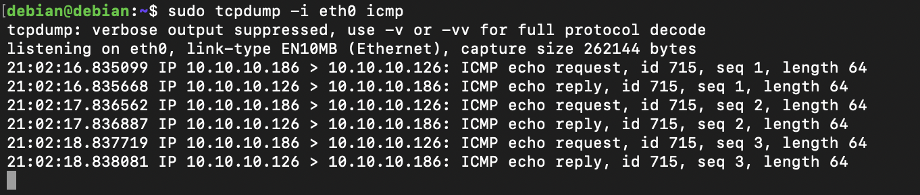

10.10.10.186 (eth0 of the NAT VM) is sending an ICMP echo request to 10.10.10.126 (vm-left).

10.10.10.126 (vm-left) responds with an ICMP echo reply to 10.10.10.186.

✅ **NAT is translating the source IP (2.2.2.124 → 10.10.10.186)**

* The original ping from vm-right (2.2.2.124) is **not directly visible** because it's **already translated** by NAT.
* The Service NAT VM **changes the source IP** to 10.10.10.186 (eth0's IP) before forwarding it to vm-left.

✅ **vm-left is replying correctly**

* The reply (10.10.10.126 → 10.10.10.186) shows that vm-left recognizes the NAT VM as the sender and responds to it.

#### **From vm-left to vm-right (*Should Work Through NAT*)**

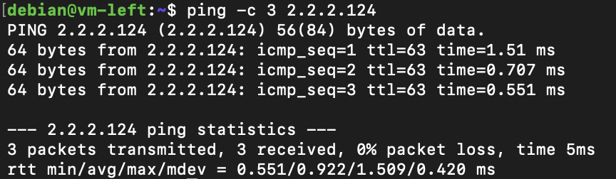

#### **Monitor Traffic on NAT VM**

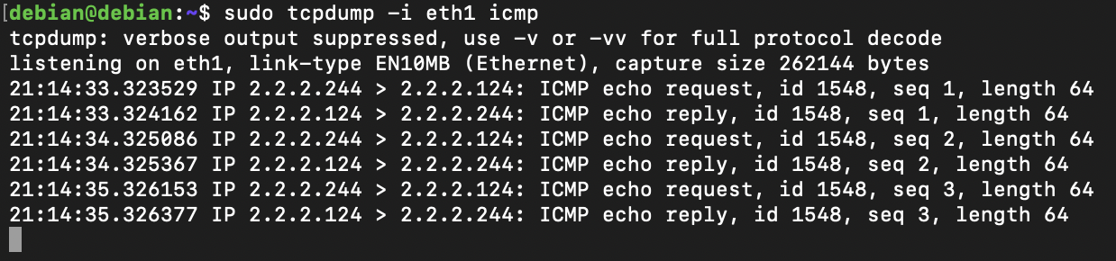

2.2.2.244 (translated IP of vm-left on eth1 of the NAT VM) is sending an **ICMP echo request** to 2.2.2.124 (vm-right).

2.2.2.124 (vm-right) responds with an **ICMP echo reply** to 2.2.2.244.

✅ **NAT is translating the source IP (10.10.10.126 → 2.2.2.244)**

* The original ping from vm-left (10.10.10.126) is **not directly visible** because it has already been **NAT-ed** to 2.2.2.244.
* The Service NAT VM **changes the source IP** to 2.2.2.244 before forwarding it to vm-right.

✅ **vm-right is replying correctly**

* The reply (2.2.2.124 → 2.2.2.244) shows that vm-right **sees the request as coming from 2.2.2.244** and correctly responds.
* The NAT VM should now **translate the response back** to 10.10.10.126 and forward it to vm-left.

This completes **Section 1: In-Network Service Chaining**. **NAT is successfully implemented**, allowing vm-right to communicate with vm-left through the **Service NAT VM**.

# **Section 2: Transparent Service Chaining**

### **Objective**

In this section, I introduced a **Layer 2 Firewall VM** into the service chaining setup. The goal is to enforce traffic flow through the firewall and block SSH traffic while allowing ICMP.

### **Network Setup**

The updated network topology is as follows:

| left-vm (10.10.10.126) ---> firewall-vm (10.10.10.242) ---> nat-vm (10.10.10.186) ---> right-vm (2.2.2.124) |
| --- |

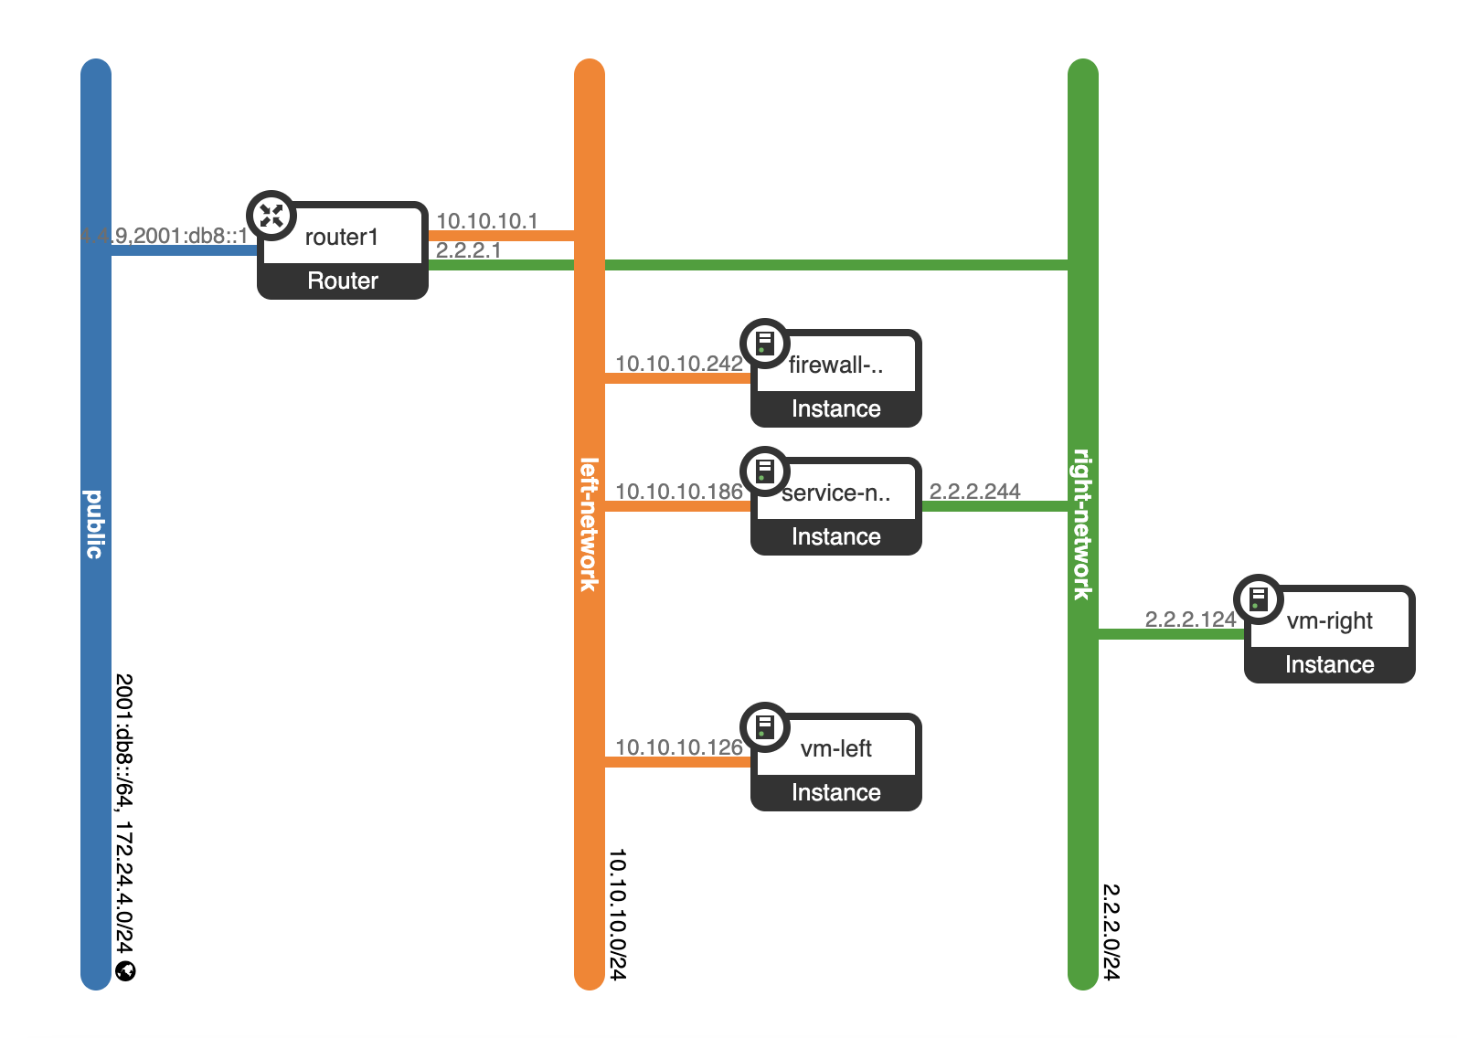

| **Component** | **Network** | **IP Address** |
| --- | --- | --- |
| **left-vm** | left-network | 10.10.10.126 |
| **firewall-vm** | left-network | 10.10.10.242 |
| **service-nat-vm** | left-network → right-network | 10.10.10.186 |
| **right-vm** | right-network | 2.2.2.124 |

Traffic must pass through firewall-vm before reaching nat-vm.

### **Firewall VM Setup**

#### **Assign IP Address and Enable Forwarding**

On **Firewall VM (10.10.10.242)**, run:

| sudo ip addr add 10.10.10.242/24 dev eth0 sudo ip link set eth0 up |
| --- |

Enable IP forwarding to allow traffic through the firewall:

| echo "net.ipv4.ip_forward = 1" | sudo tee -a /etc/sysctl.conf sudo sysctl -p |
| --- |

Now, packets can flow through the firewall.

### **Enforcing Traffic Flow Through Firewall**

To force left-vm to send all traffic through firewall-vm, I set the default gateway:

On left-vm (*10.10.10.126*):

| sudo ip route del default sudo ip route add default via 10.10.10.242 |
| --- |

Now, left-vm sends all traffic through firewall-vm and not directly to the nat-vm.

### **Firewall Rules (*iptables*) on firewall-vm**

To enforce filtering, I applied the following rules on firewall-vm:

#### **3.1. Block SSH Traffic (Port 22)**

The following rules block SSH traffic from left-vm to right-vm and vice-versa.

| sudo iptables -A FORWARD -s 10.10.10.126 -d 2.2.2.124 -p tcp --dport 22 -j DROP sudo iptables -A FORWARD -s 2.2.2.124 -d 10.10.10.126 -p tcp --sport 22 -j DROP |
| --- |

SSH traffic is now blocked.

#### **3.2. Allow ICMP (Ping) Traffic**

The following rules allow ICMP traffic from left-vm to right-vm and vice-versa.

| sudo iptables -A FORWARD -s 10.10.10.126 -d 10.10.10.186 -p icmp -j ACCEPT sudo iptables -A FORWARD -s 10.10.10.186 -d 10.10.10.126 -p icmp -j ACCEPT |
| --- |

Ping should work between left-vm and nat-vm**.**

#### **3.3. Allow All Other Traffic**

| sudo iptables -A FORWARD -j ACCEPT |
| --- |

All non-SSH traffic is allowed.



#### **3.4. Make Rules Persistent**

| sudo apt install iptables-persistent -y sudo iptables-save | sudo tee /etc/iptables/rules.v4 |
| --- |

Firewall rules remain after reboot.

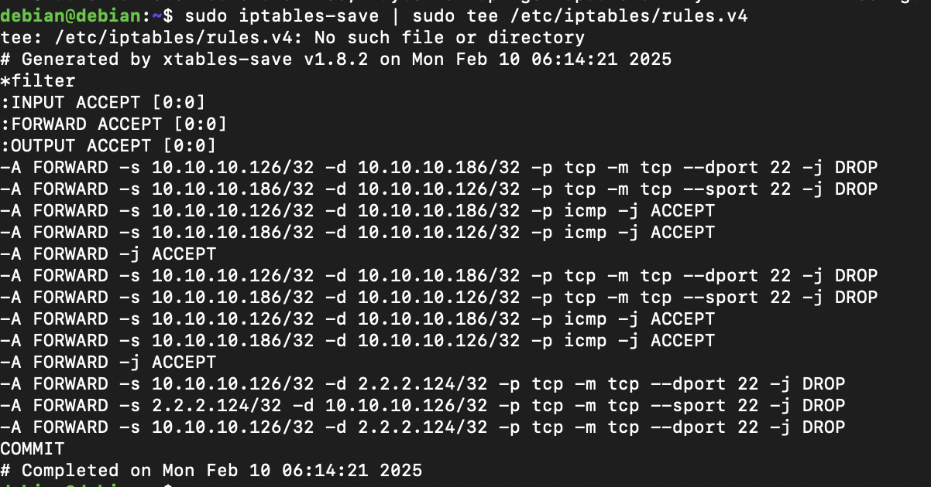

### **Verification & Testing**

#### **✅ Test ICMP (*Ping Should Work*)**

From left-vm (*10.10.10.126*):

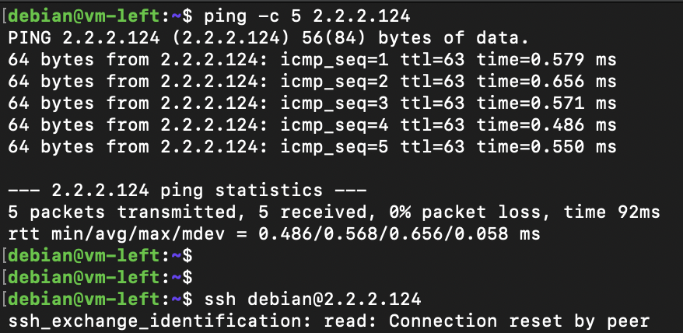

Ping succeeded.

#### **❌ Test SSH (*Should Be Blocked*)**

From left-vm (*10.10.10.126)*:

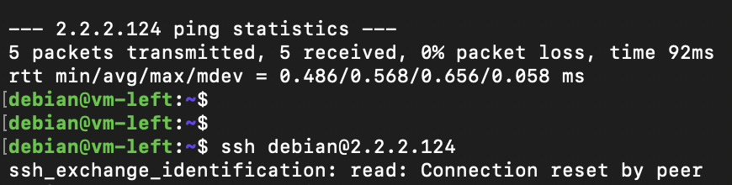

Now, firewall-vm successfully acts as a firewall, enforcing service chaining.

This completes **Section 2: Transparent Service Chaining**. Firewall VM is successfully implemented, blocking SSH from vm-right to vm-left through and vice-versa through the **Firewall VM**.